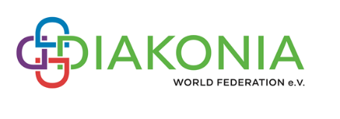
DIAKONIA Prayer Letter October 2022
As I began thinking about this prayer letter, I hold in my heart and mind the years I have served my community of deacons from the Evangelical Lutheran Church in America on the Board of Directors of both DOTAC and DIAKONIA, and all of the fabulous people I have met on this journey.. This is my last of 13 years in this position and my last Prayer Letter.
During those years these particular communites and organizations have undergone radical change. Driven, perhaps, by the arrival of COVID we have begun to hold meetings via the internet more regularly than once a year. Committees have been dreamed of and are being lived into realit. It has been a busy and hopeful time.
As I reflect on these things, I look outside and see the evidence of seasonal change. Trees are turning color and flowers are dying back in my yard. That fits my experience right now, as I “shed” these responsibilities.
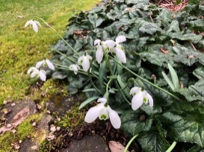
Across the world, the southern hemisphere is coming out of winter and moving into Spring. Season of death or sleeping, season of new life, awakening. Being in the north, it is hard for me to not think of the “ending” of my time in service to world DIAKONIA and all of you as a death.

And yet, and yet…..God says to Jeremiah: “For surely I know the plans I have for you, says the LORD, plans for your welfare and not for harm, to give you a future with hope.”
~ Jeremiah 29:11
God has wonderful plans for us, indivdually as I move into new places to serve, and for DOTAC, and DWF as they continue to seek out new ways to be in diakonia. God also has plans for you in your individual and cpommunal lives.

I invite you to pray with me for
- Joy in the changes God is calling you toward
- The DIAKOIA World Fedration Executive Board meeting in Neuendettelsau October 19-25. And for safe travels for those coming to and going from the meeting, October 17-18 & October 26.
- The DWF first ever Virtual Assembly, which will go live Octber 24 & 25.
- All who answer God’s call to diakonia.
- Thankfulness for seasons of change, for without change, we will surely fade away.
Amen and Amen.
Deacon Jan Cherry, ELCA Minister of Word & Service, DOTAC

